**Answers to asks (Nikolai Romanenko):**

1. Install Appium (server & required tools) as described in presentation for lecture #1.

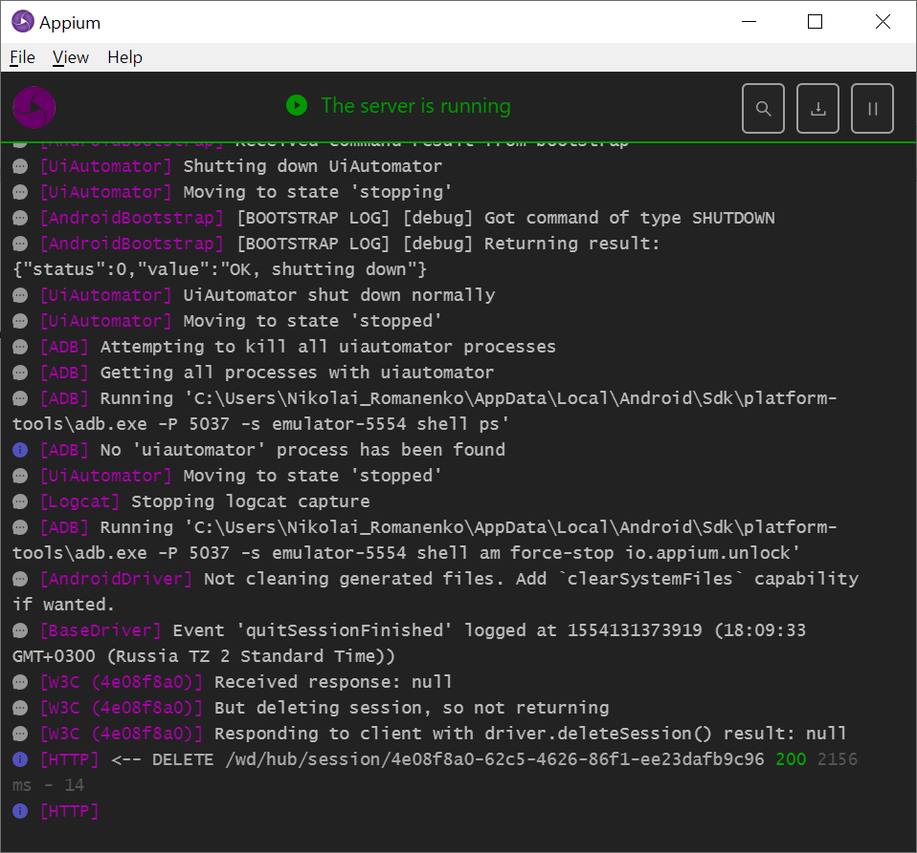

1. -done
2. -done
3. Make sure that you can run examples for native or web test on emulator as was discussed in lecture #2, and make sure that results are as expected.

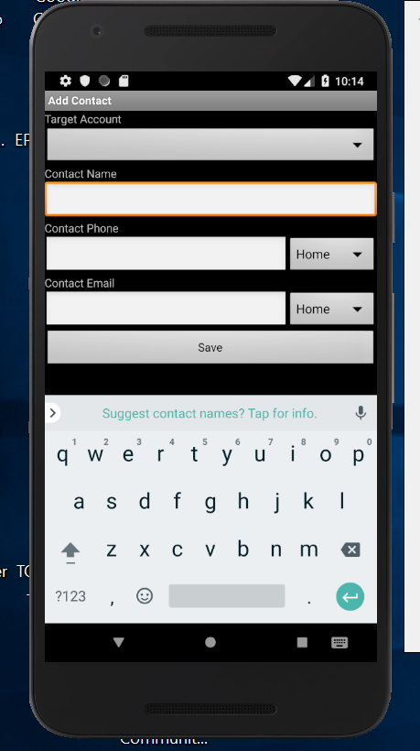 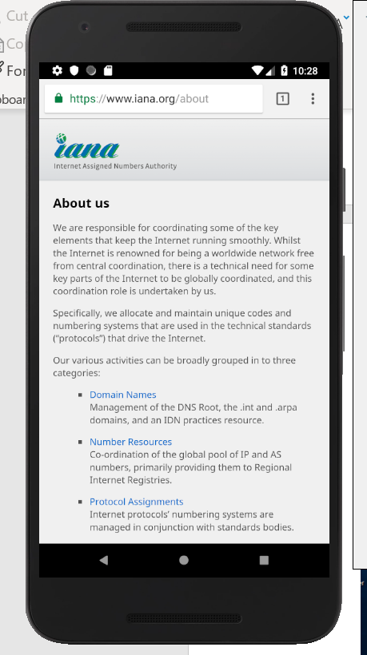

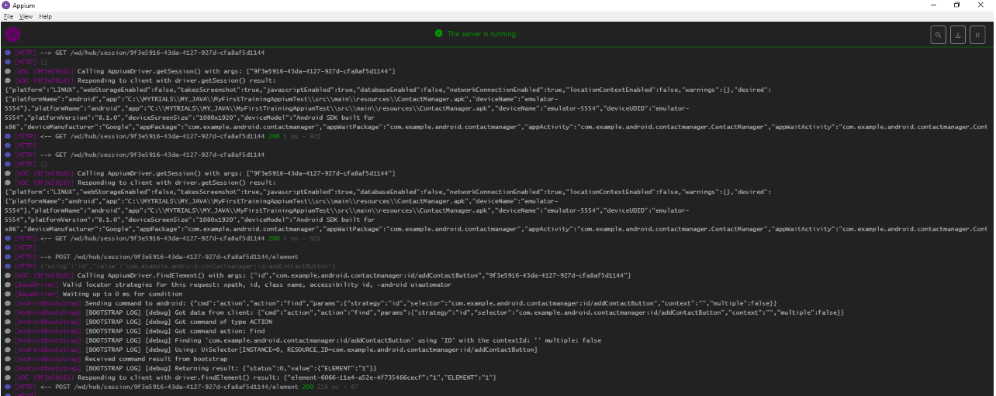

1. Modify existing tests to run on a real device. What should be changed?

wrapper.**capabilities**.setCapability(MobileCapabilityType.***DEVICE_NAME)*** should be changed from “emulator-5554” to real deviceName value

1. Connect a real device to Appium (describe required actions) and run tests. Are there any difference with run on emulator?

Yes, timings are different and driver.getSession() in the log contains different “deviceName” values, in case of physical device “deviceManufacturer” value is present …. Etc.

1. Done
2. Done